Final Project Design Phase
Computer Science - Week 11
Oct 3, 2026 - Version 0.0.4

For complete instructions and project ideas, refer to the assignment in Canvas. Specifically, review the final project requirements before you continue below. If you have not reviewed the project requirements in Canvas (you might have to go to the modules view and check the current or past week's content), you will not be able to properly complete the parts below. In addition, it may be helpful to review the information on this Drafter documentation page.

0) Project Planning and Preparation
Successful programmers spend time planning before they begin coding. After reviewing the project requirements, answer the following questions to help guide your design and development process.
- What concepts from class or previous assignments might help you complete this project? Which programming concepts (loops, conditionals, lists, classes, etc.) do you expect to use? What programming skills do you want to improve while completing this project?
The concepts from class that will help me complete this project include storing in variables, defining functions, writing conditional statements, and possibly for loops. I will also use what I have learned from previous drafter lessons and assignments to create a website with input boxes, buttons, and displayed results. I expect to use variables to store the user’s inputs, conditionals to check whether the user inputs are valid, and functions to perform the physics calculations. I may also use lists to store coordinates for the trajectory graph and loops to calculate multiple points along the object’s path. I would like to improve my ability to connect user inputs to program outputs, loops, and the basics of writing the body of functions. Improving my debugging skills would also be helpful if my LLM is incorrect.

- Which parts of the project do you expect to be the easiest for you? The hardest? Why?
I believe that writing the code will be the easiest because the LLM will be doing most of the work for me. I believe the hardest part will be instructing the LLM what to do and ensuring that it completes it correctly because it may use different techniques than I’m used to.

- Even though you have not yet designed the final project, estimate which tasks will likely require the most time and effort? Which features or components should be implemented first?
I believe the tasks that will require the most time and effort will be understanding and applying the correct physics formulas, making sure the calculations done by the program are accurate, and creating the 2D trajectory graph. If the program contains errors, debugging will also take time to make sure everything works properly. I plan to start by creating the basic website layout and setting up the input boxes for initial velocity and launch angle. Then, I will create the functions to calculate maximum height, total flight time, and horizontal distance.

- What distractions might interfere with your work and how will you minimize them? What resources will you need available while working? What questions, if any, do you still have about the assignment requirements?
Some distractions that would interfere with my work might include my devices, other school assignments, and background noise. I plan to minimize these distractions by working in a quiet environment, putting my phone away, and setting aside a specific block of time to work on this project. Some resources I will need while working include my previous assignments in class, Python and Drafter documentation, and the physics formulas required. I would like to know how complex the website interface is expected to be and whether the graph can be basic or should be interactive.

1) Site Diagram
Create a mock-up of your planned website. We suggest you make the mockup on paper, although you can also use software like PowerPoint or Slides to make a mockup. There is other design software that could also be used, but we strongly encourage you to keep it simple. Do not spend more than 15-30 minutes detailing the mock-up. Your goal should be to make a very quick and dirty diagram, to show that you have some kind of idea.

We recommend drawing each page as a rectangle, and laying out the text, buttons, and other components inside. Then, use arrows to indicate links between pages. Label each page the way you will name each function, and then put labels on the arrows to indicate what the button links. Also write down any parameters that should come into the pages.

In addition to the pages and routes, write down what fields your `State` will have, both their names and types. Think clearly about what data will need to be persistent across the entire website.

Add photo(s) or screenshot(s) of your website mock-up and labeled diagram on the next page.
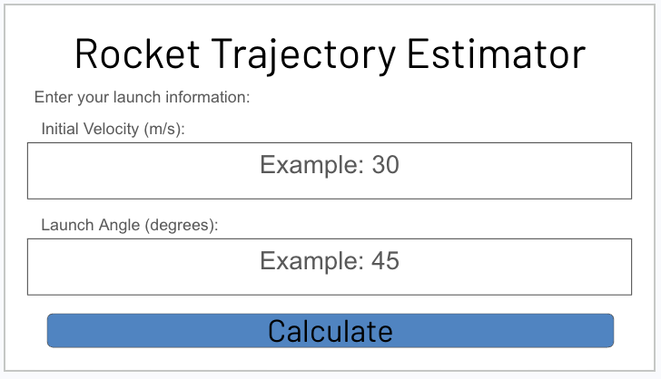

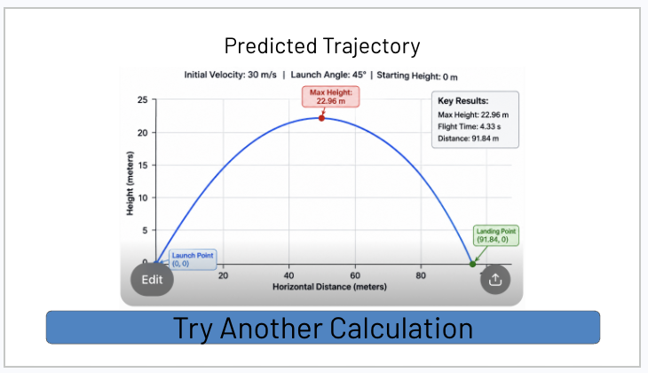
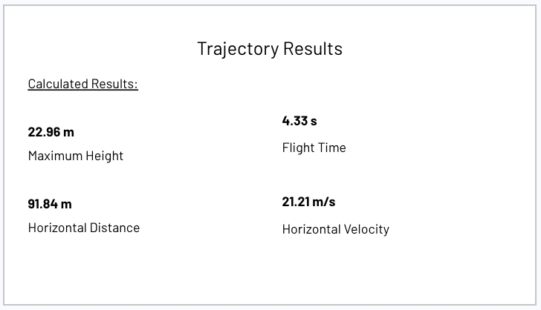
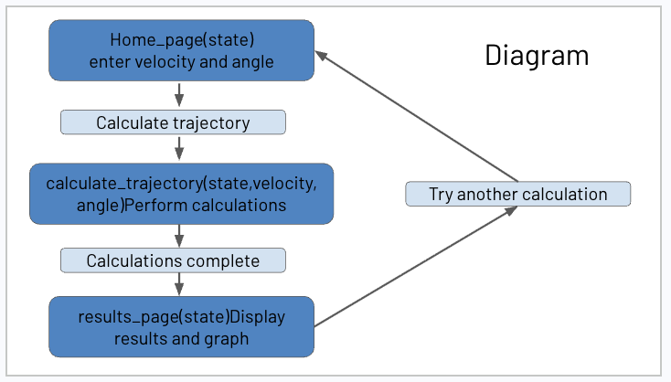

State Fields:
- velocity (float): stores initial velocity
- angle(float): stores launch angle
- max_height(float): stores calculated maximum height
- flight_time(float): stores total flight time
- horizontal)distance(float): stores horizontal distance
- trajectory_points(list[float, float]): stores coordinates for the graph

2) Implementing Requirements
This table should serve as a draft for how you will implement the requirements into your final project. You may change your ideas later on, but your final site must fulfill all the requirements.

Requirement | Implementation
Purpose/Functionality  A 1-2 sentence description of the purpose or functionality of your site | Create a Rocket Trajectory Estimator that allows user to enter launch information and calculate maximum height, flight time, and horizontal distance of an object/rocket. It will also display a 2D graph and save previous calculations.
State Dataclass Attributes  Minimum of 4 attributes, one of which must be a list/dict of instances of your second dataclass.  Briefly describe each attribute, its type, and how it will be meaningfully modified throughout the site. | - velocity(float): stores initial velocity  - angle(float): stores launch angle  - starting_height(float): stores starting height  - trajectories(list[Trajectory]): stores previous calculations
Second Dataclass  Your second dataclass, including its attributes, their types, and how they will be meaningfully modified (if they are modified) | Trajectory will contain velocity(float), angle(float), max_height(float), flight_time(float), and horizontal distance(float). Each instance represents one completed calculations using the given formulas.
Routes (minimum 7)  The names of your route functions | - home_page  - input_page  - calculate_trajectory  - results_page  - history_page  - view_trajectory  - clear_history  - about_page
Pages (minimum 5)  A brief description of the pages in your site | - Home page: the starting page of website  - Input stage: where the user inputs data  - Results page: where the results from the calculations are shown  - History page: shows the previous calculated trajectories  - About page: gives the user information about site
User Input (minimum 3)  Description of user input components (TextBox, TextArea, CheckBox, or SelectBox) and their purposes  For more information on these input types, see Drafter Documentation. | Three TextBoxes will collect initial velocity, launch angle, and starting height
If Statements (minimum 3)  Brief description of what will be evaluated in your if statements and how they will meaningfully change the logic of the site | Check whether input are valid, whether calculation history is empty, and whether calculated results are valid. This will help to ensure the calculations and information given and received by the program is correct.
Loop (minimum 1)  This loop must iterate over the list/dict of dataclass instances in your State attribute.  Description of this loop and why it is meaningful to the site | A for loop will iterate through the list of saved Trajectory instances and display each previous calculation on the history page.

LLM Conversation
If you used an LLM in any part of this work, copy and paste every part of that conversation below. Otherwise, you may be given a zero for the assignment. Obviously, these words will not all be yours, and this is the exception to the requirement at the top of this assignment that all responses be in your own words. If you did not use an LLM to assist you in this assignment, simply say so below.
Could you give me a good example of a graph that would be produced as an image?
Here is an example of what your website's graph could look like!
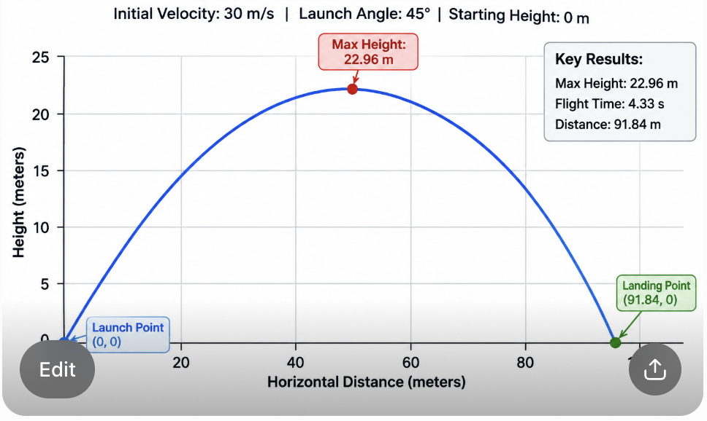It shows the rocket launching, reaching its maximum height, and landing. It also displays the calculated results beside the graph.
The example uses:
- Velocity: 30 m/s
- Launch angle: 45°
- Maximum height: 22.96 m
- Flight time: 4.33 seconds
- Horizontal distance: 91.84 m
I would use this style for your project because it is easy to understand, clearly labeled, and shows both the graph and the calculations.
Can you give me good variable names, ideas of where to use loops, lists, and if statements, and page names, please?
Absolutely! For your Rocket Trajectory Estimator, I would choose variable names that are easy to understand and make it obvious what each part of your code does. I would also organize the project around your assignment requirements: 2 dataclasses, at least 7 routes, 5 pages, 3 inputs, 3 meaningful if statements, and 1 loop.

1. Good variable names
Here are variable names I recommend using throughout your project.
Variable name | What it represents | Data type
velocity | Initial speed of the rocket | float
launch_angle | Angle at which the rocket launches | float
starting_height | Height where the rocket begins | float
gravity | Gravitational acceleration (9.8) | float
horizontal_velocity | Rocket's horizontal speed | float
vertical_velocity | Rocket's vertical speed | float
maximum_height | Highest point the rocket reaches | float
flight_time | Total time the rocket stays in the air | float
horizontal_distance | How far the rocket travels | float
trajectory_points | Coordinates used to create the graph | list
saved_trajectories | Previous rocket calculations | list
trajectory | One saved rocket calculation | Trajectory

2. Dataclasses
I recommend having two dataclasses.
First dataclass: Trajectory
This represents one completed rocket calculation.
@dataclass
class Trajectory:
velocity: float
launch_angle: float
starting_height: float
maximum_height: float
flight_time: float
horizontal_distance: float
Second dataclass: State
This stores the current information and the user's previous calculations.
@dataclass
class State:
velocity: float
launch_angle: float
starting_height: float
saved_trajectories: list[Trajectory]
The saved_trajectories list is especially important because it lets your website remember previous calculations and display them on the History Page.

3. Where to use if statements
You need at least 3 meaningful if statements. Here are some good places to put them.
If statement | What it checks | What the website does
1. Input validation | Is velocity greater than 0? Is the angle between 0° and 90°? | Displays an error if the inputs are invalid.
2. Empty history | Is saved_trajectories empty? | Displays "No previous calculations yet!"
3. Valid calculation | Did the calculation produce valid results? | Displays the results or an error message.
4. Clear history | Does the user have saved calculations? | Clears the list if there are calculations to remove.
You only need three, but having four gives you some flexibility.

4. Where to use loops
I would use a for loop on your History Page.
For example:
for trajectory in state.saved_trajectories:
# Display each saved calculation
The loop would go through every saved trajectory and display:
- Initial velocity
- Launch angle
- Maximum height
- Flight time
- Horizontal distance
Why this is useful: If the user calculates five different trajectories, the loop displays all five without you having to write separate code for each one.

5. Where to use lists
I recommend using two lists if you want to make your project more interesting.
List | What it stores | Why you need it
saved_trajectories | Previous Trajectory objects | Allows users to view their calculation history.
trajectory_points | Horizontal and vertical coordinates | Allows you to create the curved rocket graph.
For example, your graph might use coordinates like:
trajectory_points = [
(0, 0),
(10, 8),
(20, 15),
(30, 20),
(45, 23),
(60, 20),
(80, 10),
(92, 0)
]
These are example coordinates, not exact calculated values. Your actual program would calculate them based on the user's inputs.

6. Page names and route ideas
I recommend these five pages:

1. Home Page
home_page
Introduces the Rocket Trajectory Estimator and has a button to begin.
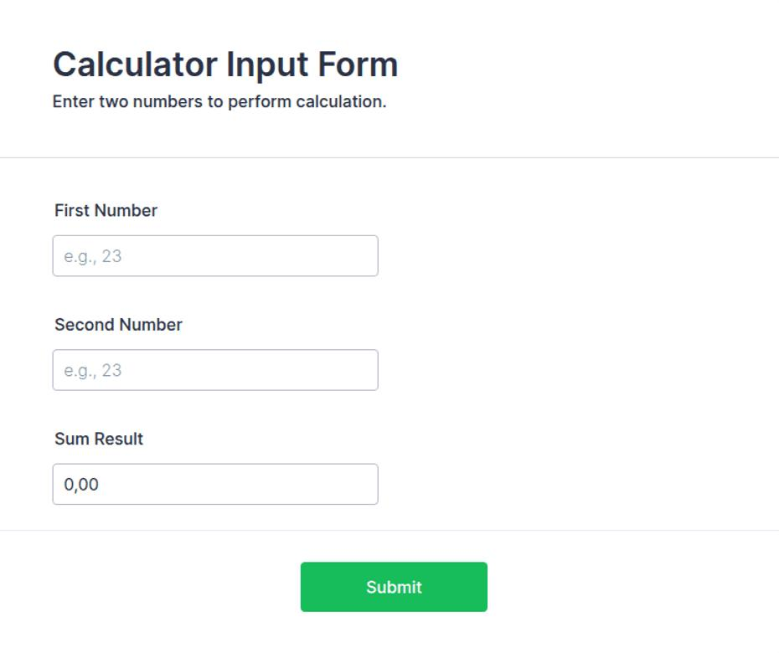
2. Input Page
input_page
Allows users to enter velocity, launch angle, and starting height.
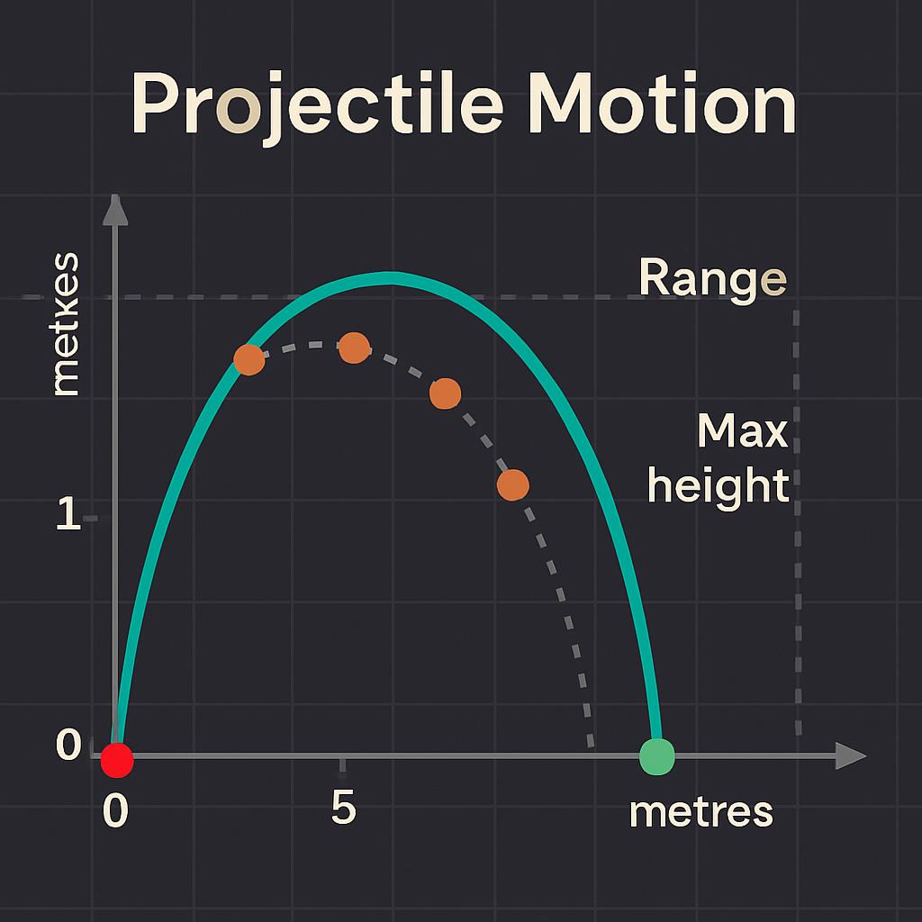
3. Results Page
results_page
Displays maximum height, flight time, horizontal distance, and the graph.

4. History Page
history_page
Displays all previously saved rocket calculations.

5. About Page
about_page
Explains how the calculator works, the physics formulas, and its limitations.

7. Seven or more route names
Remember: routes are the functions that allow users to navigate between pages or perform actions. You can have more routes than pages.
Route name | What it does
home_page | Displays the home page.
input_page | Opens the input form.
calculate_trajectory | Performs the rocket calculations.
results_page | Displays the results and graph.
history_page | Displays previous calculations.
clear_history | Deletes previous calculations.
about_page | Explains the project.
view_trajectory | Displays a selected saved calculation.
My recommendation
I would keep your project focused on these main features:
- Users enter three values.
- Your program calculates the rocket's trajectory.
- A graph displays the rocket's path.
- The calculation is saved to the History Page.
- Users can view or clear previous calculations.
This gives you a project that is manageable for an introductory Python course while still meeting the requirements and demonstrating lists, loops, dataclasses, functions, and conditionals.

Final Submission
When you are finished, download this file as a Word Document (docx) and upload the file to the appropriate assignment on Canvas.

